Ryan Helmlinger

Period 3

6/21/16

Number of vertices: 50,000

Number of edges: 150,000

Highest vertex degree: 15

The code initially generates 3 points all connected to each other. Then after that, the code continuously adds a point and then connects it to k (3) random points from the current list of points. The code does this until it reaches the set number of vertices, which in this case was 50,000.

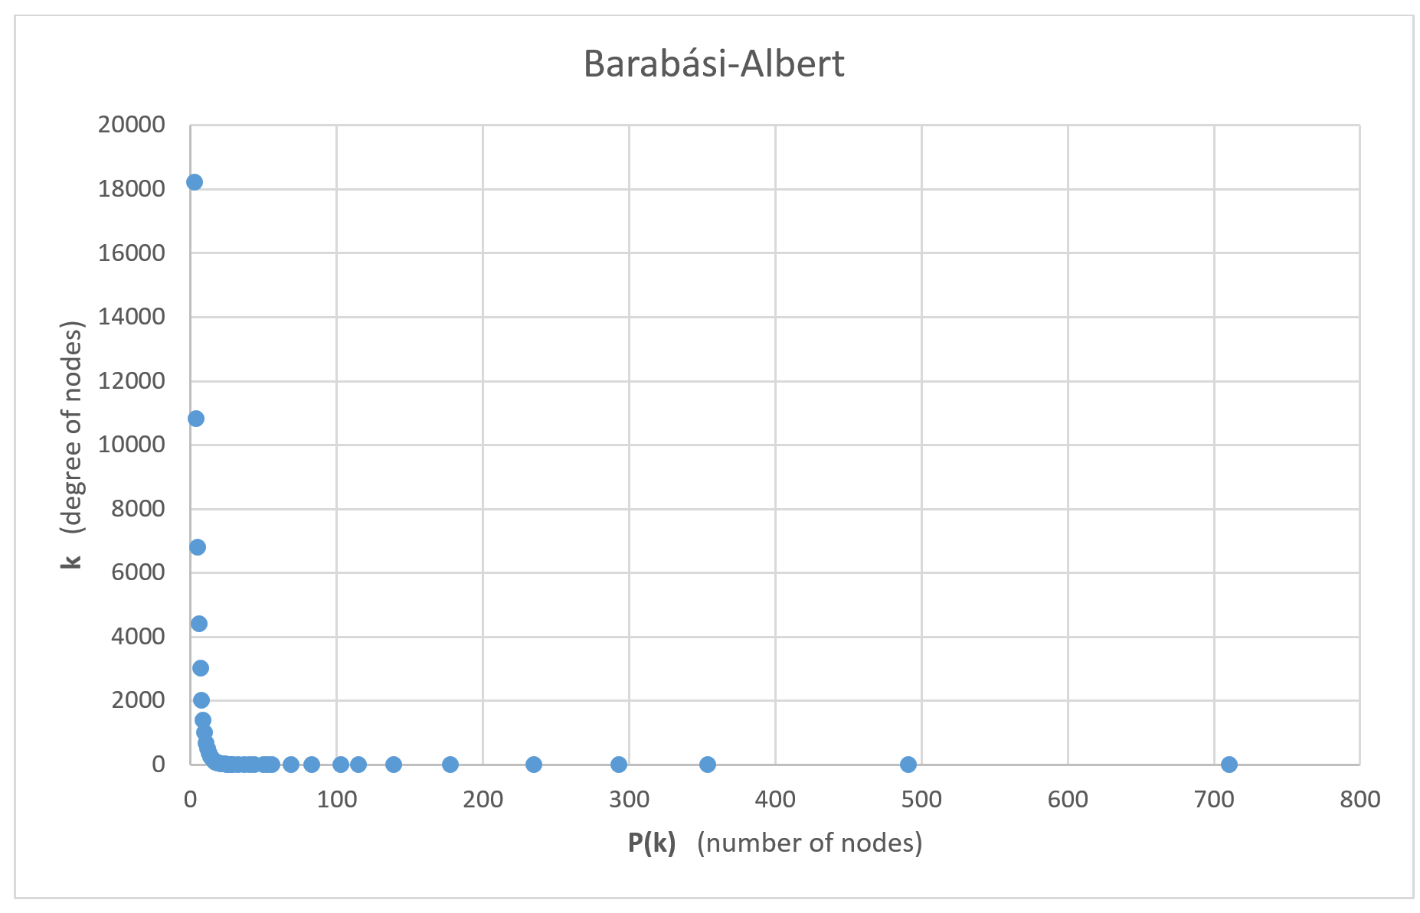

Equation of exponential regression line: y = 2703 $x^{-3}$

Number of vertices: 50,000

Number of edges: 150,000

Highest vertex degree: 711

The code initially generates 4 random points and connects them randomly to one of the other 3 points. After this, the code continuously adds points and connect them it to k (3) different points. It does this by using a probability function and it gives the higher to chance of connecting to the more popular nodes. This is repeated until a certain number of vertices is reached, which in this case is 50,000.